# Guide: Firebase/Kinvey/Postman

Introduction to Firebase, Kinvey and Postman for the ["JavaScript Applications" course@SoftUni](https://softuni.bg/courses/js-applications).

## Postman

Postman is an application for **testing APIs**, by sending **request** to the **web server** and getting the **response** back. It allows users to set up all the **headers** and **cookies** the **API** expects, and checks the response. You can download it from [here](https://www.getpostman.com/downloads/).

**Firebase**

Firebase is a **mobile** and **web** development platform. It provides a **realtime database** and **backend** as a service. The service provides developers an **API** that allows application data to be **synchronized** across clients and **stored** on Firebase's cloud. The **data** is **structured** as a **JSON** tree.

### Registration

**Register** at <https://console.firebase.google.com>. Afterwards, **create a new project** and start playing around with it in order to understand how the database works.

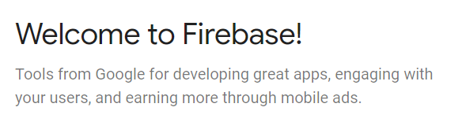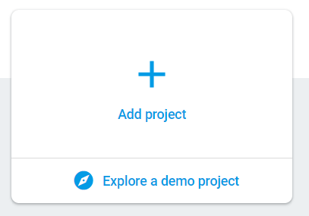

## Put Some Data in the Database

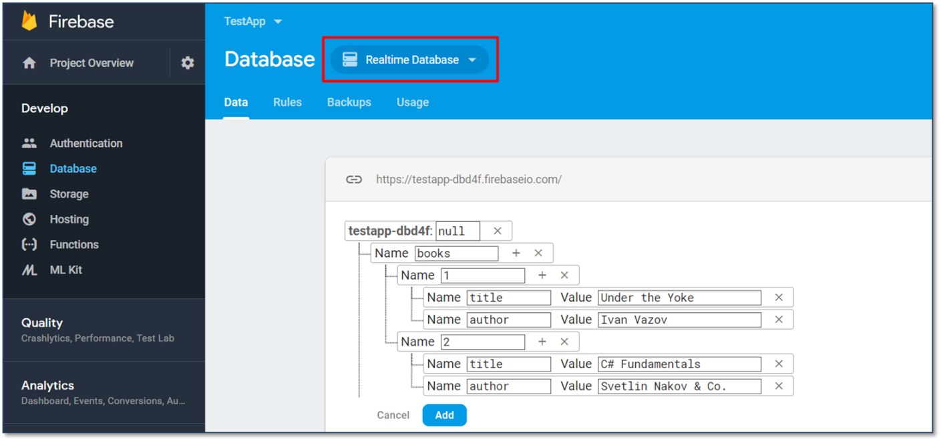

## REST API

Make sure to enable **unauthorized access** to your database. Note that this is for **educational purposes** only and you should **NOT** do it in real apps as it is a **security hole**! After you have done that, access your data through the REST API.

**GET**

<https://testapp-fc138.firebaseio.com/.json>

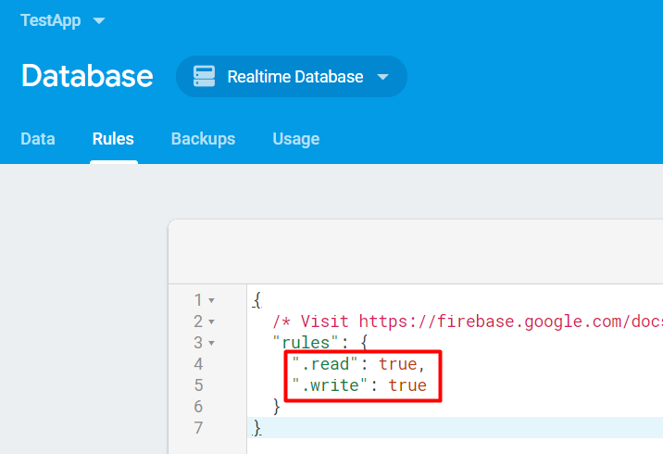

## Accessing Firebase REST API with Postman

Open **Postman** and make a **GET** request to receive all of the information in your database. In our case that would be a list of all the available books. 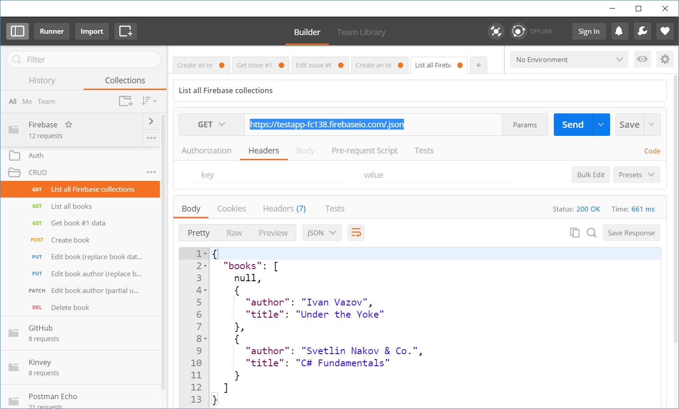

## Kinvey

Kinvey is a **BaaS** provider that makes it easy for developers to set up, use, and operate a **cloud back-end** for their apps. It holds **users** (API for creating an account), **user data** and **data collections** (API for CRUD operations).

## Register

The first thing to do is create an account in [Kinvey](https://console.kinvey.com/sign-up), followed by creating an app.

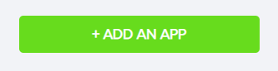

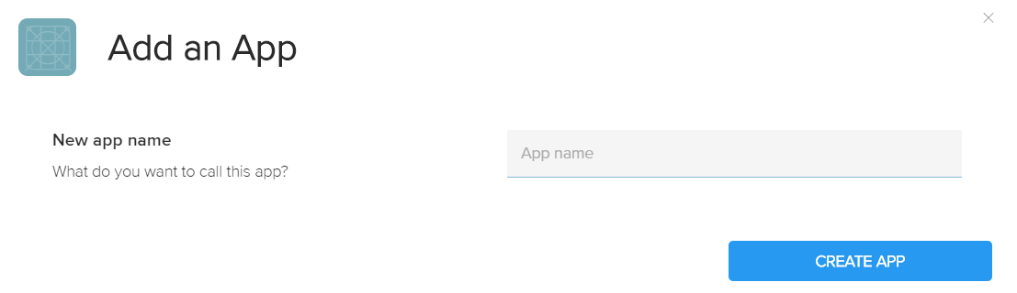

In order to get the **App ID** and **App Secret** of your app, you need to click on the **Development** button. For more information, see the picture below.

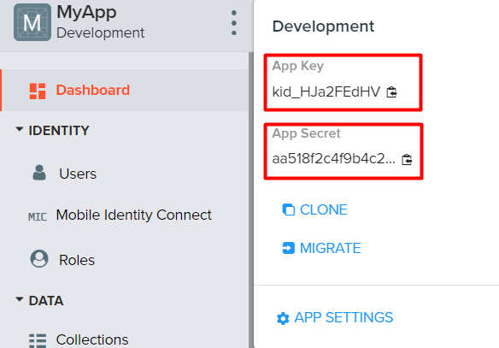

## Create a User

In order to **create a user**, click on "**Users**" right below "**Identity**" in the menu.

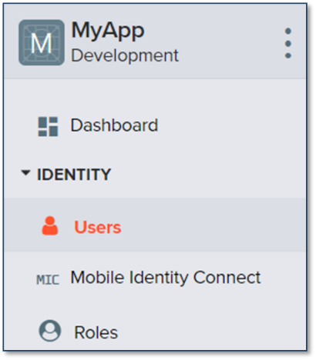

After that, you will see two buttons. Click on the "**Add User**" one.

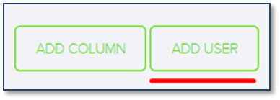

Then the following form will show up:

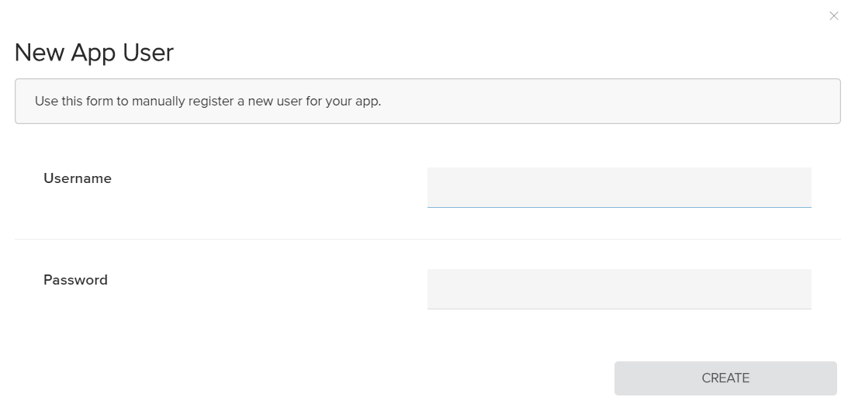

Write "**guest**" in both of the **username** and **password** fields. Then click on the "**Create**" button.

## 2.3 Create a Data Collection

In order to **create a collection**, click on "**Collections**" right below "**Data**" in the menu.

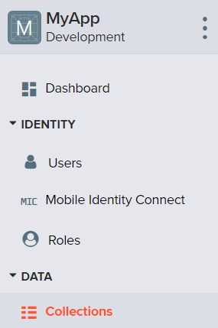 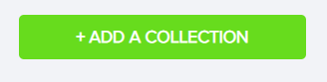

Then the following form will show up. Write the **name of your collection** in the field (for example, you can name it *posts*).

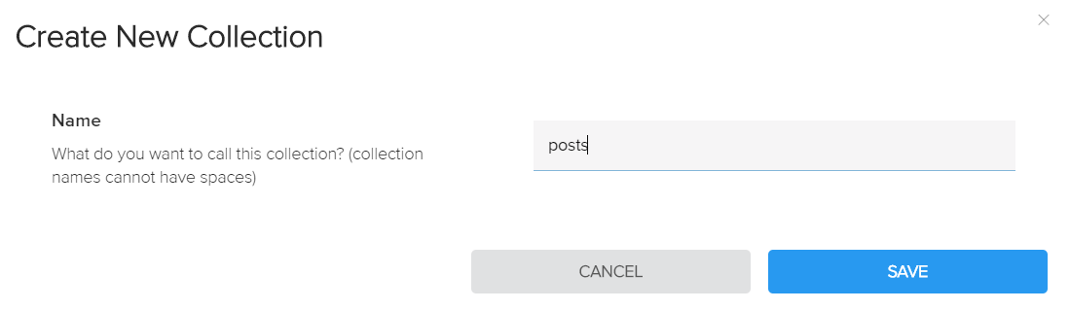

## Create Data Columns

Now it is time to **create** some **data columns** for our collection. Click on the "**Add Column**" button. Provided we have named it "posts", it would be appropriate for a single post to have a **title** and a **body**.

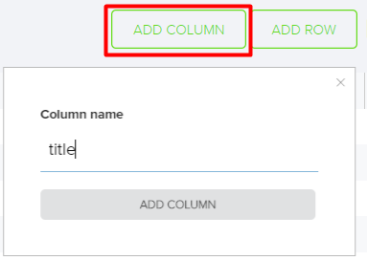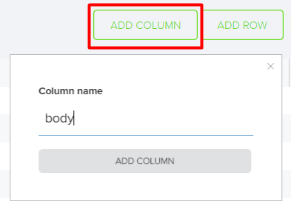

## Create Data Rows

Click on the "**Add Row**" button in order to **create** some **rows** for your collection and **insert data** in them.

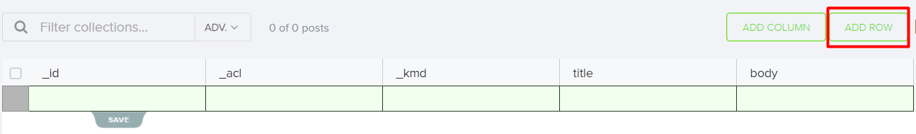

Manually fill in the "**title**" and "**body**" fields with the information provided below and **save** it.



After having clicked on "save", you will see the following:

